Engineering Parameters of Musical Singing Aesthetics and Application to Affective Computing

G Tremberger, S Dehipawala, D Lieberman, T Cheung

CUNY Queensborough Community College, Bayside NY 11364 USA (Contact: tcheung@qcc.cuny.edu)

Keywords: correlated randomness, fractal dimension Shannon entropy, Fast Fourier Transform

Abstract
The engineering parameters of musical singing aesthetics has been studied in terms of statistical analysis of the corresponding Fast Fourier Transform coefficient series. The Shannon information entropy, coefficient of variation CV and fractal dimension FD were evaluated in relationship to the aesthetical values assigned to a diva and learners. The FD was computed with the Higuchi fractal algorithm. A short singing in the Do Re Me song in The Sound of Music movie was used to demonstrate that the Shannon entropy, CV and FD analyses would provide engineering parameters to measure the musical singing aesthetics when the diva parametric values are taken as the gold standard. The learners could use the diva parameters to gauge their learning progress. The applications to machine affective computing with artificial neural network approach, m-Learning Apps, adolescent suicidal breathier speech analysis, and engine sound diagnostic practice are discussed.

1 Introduction
The engineering parameters of musical singing aesthetics has been studied in terms of statistical analysis of the corresponding Fast Fourier Transform FFT coefficient series. The presence of correlated randomness in a singing time series in principle is what separates singing from random noise. Presumably it is the presence of such correlated randomness that builds up the aesthetic values and those top singers are called divas. In this project, the Shannon information entropy, coefficient of variation CV and fractal dimension FD were evaluated in relationship to the aesthetical values assigned to a diva and learners. Aesthetics evaluation studies in engineering designs have been published [1, 2, and 3]. On the other hand the aesthetics embedded in musical singing and the lack numerical parameters had generated compliant against singing instructor [4]. The authors in Reference 4 said “One of the most critical limitations in music education is that we have classroom teachers who rarely, if ever, sing with their students. The gap between those in educations who sing and offer musical activities to their students and those who do not is greater than ever. The "non-singer" mentality persists in educational communities and is not being addressed in music education circles…” It is the aim of this project to provide objective engineering parameters to quantify musical singing aesthetics.

The mathematical content in music has been studied [5, 6, 7, 8, and 9]. However none of the reports that we encountered provide a practical engineering algorithm to probe the correlated randomness in a diva’s singing that would easily be adaptable to mobile Apps for comparative evaluation and/or learning purpose. The results of project also showed that practical engineering algorithms to quantify musical singing aesthetics are possible.

2 Materials and Methods
The singing signal FFT coefficient series or intensity can be expressed with the follows. The observational intensity (Int) random series with equal time intervals could be used to generate a difference series (Int(j)-Int(i)) for different lags in the time variable. The non-normalized apparent length of the time series curve is simply L(k) = Σ absolute value of (Int(j)-Int(i)) for all (j-i) pairs that equal to k. If the Int(i) is a fractal function, then the log-graph ln (L(k)) versus ln (1/k) should be a straight line with the slope equal to the fractal dimension [10]. Note that taking a slope is equivalent to assessing the y-average in comparative analysis of identical x-value finite data. A Gaussian noise data series usually has a fractal dimension of approximately 2. A short series (100 data points) can have a fractal dimension exceeding 2. A Higuchi fractal algorithm result is shown in Figure 1.

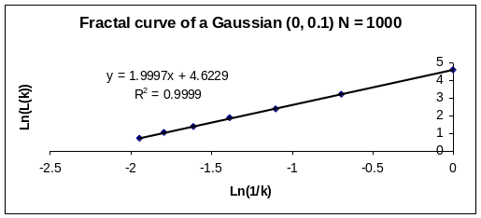
Figure 1: Fractal curve of Gaussian (0, 0.1) The series had 1000 data points

3 Results of Statistical Analysis
The case of a short singing in the Do Re Me song in The Sound of Music was used to demonstrate that statistical analyses in terms of FD, CV, Shannon entropy would provide engineering parameters to measure the musical singing aesthetics when the diva parametric values are taken as the gold standard. The Youtube Sound of Music Do Re Me (http://www.youtube.com/watch?v=xIjobdArtiA) contained a segment by the diva Julie Andrews at 2:00 time frame followed by the children learners at 2:06 time frame. The diva’s and the learners’ FFT series were analysed. Each series contained 8192 entries. A sub-series with N = 100 was used to generate FD, CV, and Shannon entropy values from the 8192-entry series. The FD result is displayed in Figure 2. The singing of Julie Andrews has a more dynamic range in terms of fractal dimension values. The fractal dimension distribution of a random series each with N = 100 data points is displayed in Figure 3. Julie Andrews can achieve fractal dimension values around 1.3, which is outside the results of our simulation with 40,000 N= 100 series. The children learners were achieving fractal dimension values around 1.4 when following Andrews’ singing.

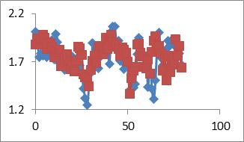
Figure 2: The fractal dimensions (y-axis) versus the sub-series index. The diamonds represent the diva Julie Andrews singing and the squares represent the children learners singing.

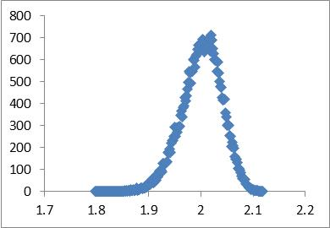
Figure 3: The fractal dimension distribution of a random series each with N = 100 data points. A total of 40,000 simulations were performed.

The dynamic range of Andrews’ singing when compared to the children learners’ singing is also illustrated in a fractal dimension histogram as shown Figure 4. The FD histogram CV values are 0.102 for Julie Andrews’ singing and 0.076 for Children Learners’ singing. A relative change of about 25% is indicative of the dynamic range of Julie Andrews’ singing when compared to the Children Learners’ singing.

Parallel analysis using CV was performed on the N = 100 sub-series. The sub-series CV values versus sub-series index result is shown in Figure 5. The corresponding histogram analysis result is shown n Figure 6 and that the CV for Julie Andrews’ singing histogram-CV data of N=100 sub-series was found to be at 0.128 and Children Learners’ singing 0.123. It is interesting to note that the CV values given the 8192 series are 1.11 for Julie Andrews’ singing and 1.01 for Children Learners’ singing.
.
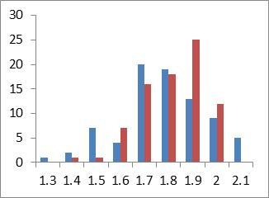
Figure 4: The FD histogram of the data shown in Figure 2. The left-side bars on the FD outcomes represent Julie Andrews’ singing and the right-side bars Children Learners’ singing.

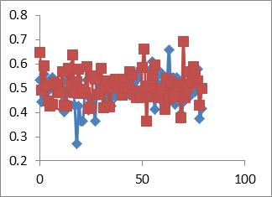
Figure 5: The CV values (y-axis) versus the sub-series index. The diamonds represent the diva Julie Andrews singing and the squares represent the children learners singing.

The Shannon entropy formula representing a coefficient-squared value as a probability value in Reference 11 was used to calculate the entropy value [11, 12, and 13]. The Shannon entropy value for Julie Andrews’ singing (N= 8192) was found to be at 10.76 bits and the Children Learners’ singing 10.83 bits. The Shannon entropy difference would increase with sub-series analysis. The Shannon entropy on the first half series N = 4192 for Julie Andrews’ singing was found to be 11.3 bits and Children Learners’ singing 11.0; where a relative change of about 3% is observed. Shannon entropy and CV statistics are independent of the data ordering position but FD algorithm would retain the data ordering position in a given time series.

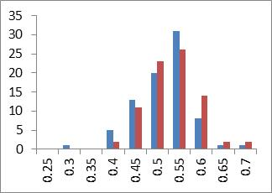
Figure 6: The histogram of the CV-data shown in Figure 5. The left-side bars on the CV outcomes represent Julie Andrews’ singing and the right-side bars Children Learners’ singing.

4 Discussion
It is note that fractal dimension does not have additive property. The FD values of two sequential time frames would not have an average close to the FD value of the single time frames containing the two sub-time-frames. The case of a short singing of the song “Il Condor Con Testo” by Gigliola Cinquetti in Italian (available in http://www.youtube.com/watch?v=HhZC2daCzck) was used for illustration. The video time: 40--46, 46--59, 40—59 were analyzed and the result is shown in Figure 7. The combined series shows a FD range from about 2.1 to 1.5 while the two sub-series show FD ranges from 1.9 to 1.1. The subdivision scheme in the proposed fractal algorithm seems to offer better effectiveness to quantify aesthetics in musical singing.

Machine affective computing or artificial neural network or artificial intelligence could be for evaluation and for learning. A singing contest judge could be an artificial neural network with supervised or unsupervised learning programming using databases of divas in which a new singer would be rank among the divas and the competitors in that singing contest. Machine affective computing studies in music and emotion expressed in painting have been documented in student thesis databases [14, 15, and 16]. Machine Learning studies in fractals have been published as well [17, 18]. The use of fractals theory via Problem-Based Learning (PBL) in the teaching of a computer programming course was also reported [19]. The Reference 19 education report pointed out that the incorporation of fractals arising from program complexity discussion during the teaching of a Turing Machine would enhance students’ performance in problem solving skill. It would be interesting in future studies to probe the pedagogy effectiveness of incorporating a fractal evaluation-learning tool based on engineering parameter quantification in the teaching of aesthetics in musical singing, painting, etc.

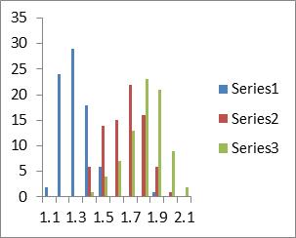
Figure 7: The FD histogram of the Gigliola Cinquetti’s singing. Series-1 represents the time frame 40-46 result. Series-2 represents the time frame 46-59 result. Seires-3 represents the time frame 40-59 result.

The extension to voice pattern analysis would open up research topics in science of crime, evaluation of adolescent suicidal breathier speech in psychiatric clinics, relationship monitoring, etc [20]. A speech analyst would be able to quantify the FD variation in a speech and help her/him to improve on the speech sub-segments with parametric values as guidance in a m-Learning App or software. A person in a relationship would be able to use an m-Learning App to store the FD or related parametric values of her/his partner’s voice and to build a baseline such that a deviation would suggest lying, stress, etc. when recording voice is consistent with local laws. This m-Learning App example could supplement m-Health Apps for better mental health. A recent report said that there are a few objective gene variants that would account for subjective well-being or happiness [21]. The research was based on genome-wide analyses using about 300,000 human subjects across the world. In the same token, the engineering parameters quantifying musical singing and melody would also add objective and remove the subjectivity in aesthetics judgment. This paper echoes the trend in the scientific inquiry of human specific subjectivity in affective computing.

The regular practice of listening to engine sound for improving performance and safety has been accepted in technology. A recent report said that Joint European Torus fusion reactor (JET) uses loudspeakers to monitor the environment; and they had at least once be able to track down a loose clamp in the torus's immense and complicated structure [22]. In the Reference 22 video report, the sound listening ability was attributed to “hundreds of millions of years of evolution” in Transcript time frame 2.54. Whether this is the motivation of transcribing the Comet-67 magnetic field variation data below 20 Hz to a song above 50 Hz by ESA for better diagnostic analysis is an interesting question [23]. In any event, a FD quantification of sound time series data would help to foster better engine sound diagnostic practice.

5 Conclusions
The engineering parameters of musical singing aesthetics has been studied in terms of statistical analysis of the corresponding Fast Fourier Transform coefficient series. The fractal dimension analysis of a singing series and its sub-series was found to be effective in the separation of a diva’s singing from learners’ singing. The learners could use the diva parameters to gauge their learning progress with Apps that could also be based on machine affective computing. Future studies could include the engineering parametric classification of aesthetics among divas.

Acknowledgements
The authors thank Alexei Kisselev for laboratory support. The project was partially supported by several CUNY grants.

References
[1] Anthonie Meijers, “Aesthetic Values in Technology and Engineering Design” Handbook of the Philosophy of Science, volume 9, pp. 1031-1068 (2009)
[2] Sonderegger A, Zbinden G, Uebelbacher A, Sauer J., “The influence of product aesthetics and usability over the course of time: a longitudinal field experiment.” Ergonomics. volume 55 pp713-730 (2012)
[3] R. Roy, P. Baguley, L. Reeve, “ Understanding the Link between Aesthetics and Engineering in Product Design”, Proceedings of the 17th CIRP Design Conference, pp 155-164 (2007)
[4] Louise M. Pascale, “Dispelling the Myth of the Non-Singer: Embracing Two Aesthetics for Singing”, Journal: Philosophy of Music Education Review, volume 13, pp. 165-175 (2005)
[5] M. Bigerelle, A. Iost, “Fractal dimension and classification of music”, Chaos, Solitons & Fractals, volume 11, pp2179–2192 (2000)
[6] Güngör Gündüz and Ufuk Gündüz, “The mathematical analysis of the structure of some songs”, Physica A: Statistical Mechanics and its Applications, volume 357, pp 565–592, (2005)
[7] Zhi-Yuan Su and Tzuyin Wu, “Multifractal analyses of music sequences”, Physica D: Nonlinear Phenomena, volume 221, pp188–194 (2006).
[8] Zhi-Yuan Su, Tzuyin Wu, “Music walk, fractal geometry in music”, Physica A: Statistical Mechanics and its Applications, volume 380, pp 418–428,(2007).
[9] Atin Das, Pritha Das,” Fractal analysis of songs: Performer’s preference”, Nonlinear Analysis: Real World Applications, volume 11, pp 1790–1794 (2010).
[10] T. Higuchi, "Approach to an irregular time series on the basis of fractal theory", Physica D, volume 31, pp277-283, (1988).
[11] El-Kishky, Ahmed. "Assessing entropy and fractal dimensions as discriminants of seizures in EEG time series." Information Science, Signal Processing and their Applications (ISSPA) 11th International Conference on. IEEE (2010).
[12] Coifman, R.R.; M.V. Wickerhauser, ”Entropy-based Algorithms for best basis selection,” IEEE Trans. on Inf. Theory, volume. 38, 2, pp.713–718. (1992)
[13] Donoho, D.L.; I.M. Johnstone, ”Ideal de-noising in an orthonormal basis chosen from a library of bases,” Comptes Rendus Acad. Sci Paris, Ser. I, Transcation volume 319, pp. 1317– 1322. (1994)
[14] Pot, Wouter, “A machine learning approach for generating expressive musical transcriptions”, University of Twente Student Theses Computer Science, http://purl.utwente.nl/essays/598 (2007).
[15] P Mennen , “Pattern recognition and machine learning based on musical information”, Tilburg University. FGW. Communicatie en Informatie 2011. http://tilburguniversity.worldcat.org/search?q=scr.uvt.nl:5014988 (2011).
[16] E. Brinkman, “Recognition of the emotion in abstract expressionistic paintings using a machine learning approach”, Univ of Twente Student Theses, Computer Science, http://purl.utwente.nl/essays/863 (2008).
[17] S. Arjunan, et al. “A machine learning based method for classification of fractal features of forearm sEMG using Twin Support vector machines” 32nd Annual International Conference of the IEEE EMBS, pp. 4821 – 4824 (2010).
[18] Peter Bloem, “Machine learning and fractal geometry”, Amsterdam University Student Theses 2010, www.scriptiesonline.uba.uva.nl/341971 (2010).
[19] H. Pereira, G.F. Zebende, M. A. Moret, “Learning computer programming: Implementing a fractal in a Turing Machine”, Computers & Education, volume 55, pp 767–776 (2010).
[20] Verena Venek, Stefan Scherer, Louis-Philippe Morency, Albert Rizzo and John Pestian, “Adolescent Suicidal Risk Assessment in Clinician-Patient Interaction” IEEE Transactions on Affective Computing, Early Access Articles, volume PP , Issue: 99, (2016).
[21] Okbay A, Baselmans BM, De Neve JE, Turley P, Nivard MG, Fontana MA, et al,”Genetic variants associated with subjective well-being, depressive symptoms, and neuroticism identified through genome-wide analyses” Nature Genetics, early access, April 18 (2016).
[22] Tom Scott, “Help, My Fusion Reactor’s Making A Weird Noise”, April 25 2016, https://www.youtube.com/watch?v=IrtGp8hv-0Y
[23] I. Richter, C. Koenders, et al.,”Observation of a new type of low-frequency waves at comet 67P/Churyumov-Gerasimenko”, Ann. Geophys., volume 33, 1031–1036 (2015).

